A Stochastic Spacetime Substrate Model for Continuous Universe Nucleation
Abstract
This document presents a cosmological framework in which spacetime is treated as a pre-existing, effectively infinite substrate within which localized universe-forming events occur. These events arise from stochastic processes governed by a probability distribution defined over spacetime. Each event initiates a phase transition that produces a rapidly expanding region, which evolves as an independent universe. The model leads naturally to continuous universe creation, rare but possible interactions between expanding regions, and an infinite ensemble of universes. This framework overlaps with established ideas in inflationary cosmology while maintaining a distinct ontological assumption that spacetime exists independently of any individual universe.

1. Introduction: Motivation and Scope
Standard cosmological models describe the expansion of a hot, dense early state but do not fully explain the origin of that state. In conventional interpretations, the Big Bang represents the beginning of spacetime itself.
This model proposes an alternative interpretation. The Big Bang is not the beginning of all existence, but rather a localized nucleation event occurring within a pre-existing spacetime substrate.
The goal of this framework is to reinterpret early-universe cosmology by introducing a global spacetime background and a stochastic mechanism for repeated universe formation.

2. The Spacetime Substrate
2.1 Ontological Status
The spacetime substrate is treated as the fundamental structure of reality. It is not an empty void but a physically meaningful entity with intrinsic properties that govern its behavior.
In contrast to models in which spacetime emerges from more fundamental constituents, this framework assumes spacetime itself is primary.
2.2 Physical Laws as Emergent Behavior
Within this model, the laws of physics are not arbitrary but arise from the properties of the substrate. Interactions such as gravity and electromagnetism are interpreted as consistent dynamical behaviors permitted by the structure of spacetime, as described by general relativity and quantum field theory.
All universes formed within the substrate therefore share a common foundational framework, even if their local conditions differ.
2.3 Effective Infinity
The substrate is assumed to be either mathematically infinite or sufficiently large that boundary effects are negligible. For all practical purposes, it behaves as an infinite system.
This implies that events governed by nonzero probability will occur repeatedly across spacetime.

3. Statistical Necessity of Universe Formation
If the conditions required for universe nucleation exist within the substrate, and if the substrate is effectively infinite, then universe formation becomes a statistical certainty rather than a unique EVENT.
Let λ(x, t) represent the probability per unit volume per unit time of a nucleation event. If λ is nonzero across spacetime, then:
- universe formation occurs continuously
- infinitely many universes are generated over time
This transforms the Big Bang from a singular unexplained EVENT into a recurring physical process.

4. The Nucleation Mechanism
4.1 Definition of a Nucleation Event
A Big Bang is defined as a localized phase transition within spacetime. A region transitions into a high-energy vacuum state that drives rapid expansion.
This process is consistent with models of vacuum instability and inflation, particularly those described in cosmic inflation.
4.2 Phase Transition Dynamics
The nucleation process proceeds as follows:
A stochastic fluctuation occurs within the substrate. This fluctuation causes a localized region to enter a high-energy vacuum state. The vacuum state exhibits negative pressure, producing repulsive gravitational effects that drive exponential expansion.
Following this expansion phase, the vacuum decays into a lower-energy state. The stored energy is converted into particles and radiation, initiating standard cosmological evolution within the newly formed universe.
4.3 Absence of Required Singularities
This model does not require singularities as physical objects. Universe formation arises from quantum instabilities or field dynamics rather than from infinitely dense points.

5. Probability Distribution Over Spacetime
5.1 Rate Function
Universe formation is governed by a rate function λ(x, t), which defines the likelihood of nucleation at any point in spacetime.
5.2 Homogeneous Case
In the simplest case, λ is constant. This produces a uniform Poisson process in spacetime, leading to continuous and statistically uniform universe creation.
5.3 Inhomogeneous Extensions
More complex models allow λ(x, t) to vary. This introduces spatial and temporal structure into the distribution of universes, allowing for clustering, quiet regions, and varying rates of formation.

6. Dynamics of Expanding Universes
6.1 Independent Evolution
Each nucleated universe evolves independently after formation. Its physical laws are determined by the underlying structure of the substrate, while its initial conditions arise from local fluctuations.
6.2 Horizon of Isolation
Due to the effective size of the substrate, universes are typically separated by distances that prevent interaction. Each universe behaves as an isolated region, analogous to an island within a vast system.
6.3 Collisions and Overlap
Although rare, collisions between expanding universes are possible. These events occur when nucleation happens in sufficiently close proximity. Such interactions may produce observable signatures within affected universes.

7. Continuous Creation and the Infinite Ensemble
7.1 Steady-State Multiverse
While individual universes have finite lifetimes and origins, the ensemble of universes is eternal. New universes are continuously formed as long as the nucleation rate remains nonzero.
7.2 Infinite Multiplicity
The model predicts an infinite number of universes, including the possibility of repeated or nearly identical configurations.
7.3 Statistical Challenges
The existence of infinite universes introduces the measure problem. Since all EVENTएं occur infinitely often, defining meaningful probabilities requires additional structure.

8. Philosophical Implications
This framework removes the uniqueness traditionally associated with the Big Bang. Universe formation becomes a repeatable and statistically inevitable process.
The model shifts cosmology away from a single origin event and toward a continuous process of cosmic instantiation. Our universe is not a singular beginning, but one realization within an ongoing system governed by the properties of spacetime itself.

9. Relationship to Existing Theories
This model shares structural similarities with inflationary cosmology and vacuum decay models. However, it differs in its treatment of spacetime as a pre-existing global structure rather than a feature emerging solely from local dynamics.
It can therefore be interpreted as a reinterpretation of known mechanisms within a broader ontological framework.

10. Open Questions and Future Work
Several key challenges remain:
The physical origin of the rate function λ(x, t) must be derived from underlying principles.
The conditions governing collision frequency and observable consequences require further study.
The measure problem must be addressed to produce testable predictions.

11. Conclusion
This document outlines a cosmological framework in which spacetime serves as a global substrate supporting stochastic universe formation. By introducing a probability distribution over spacetime, the model provides a mechanism for continuous universe creation without requiring spacetime itself to originate from any single event.
The result is a steady-state multiverse in which universe formation is an ongoing, statistically inevitable process.

12. Thermodynamics of the Spacetime Substrate
12.1 Introduction
If the spacetime substrate is treated as a physical system, it must possess thermodynamic properties. In particular, it must have an energy density, support fluctuations, and evolve according to conservation laws. Since universe nucleation events draw upon the substrate, the long-term behavior of the model depends on how energy and entropy are distributed and recycled within this system.
This section explores the thermodynamic consistency of the substrate and its implications for continuous universe formation.

12.2 Energy Considerations
Universe nucleation is modeled as a localized phase transition into a high-energy vacuum state, followed by expansion and reheating. This process requires a source of energy.
In a closed system with finite energy density, repeated nucleation events would reduce the available free energy over time. This would lead to a gradual decline in nucleation rates and ultimately a state of thermodynamic equilibrium in which no further universe formation is possible.
However, this outcome conflicts with the assumption of continuous universe creation. Therefore, either the substrate is effectively infinite, or it operates under a mechanism that prevents net depletion of usable energy.

12.3 Open and Effective Infinite Systems
If the substrate is effectively infinite, then local energy extraction through nucleation events does not significantly alter its global properties. In this case, the nucleation rate remains approximately constant over time, and universe formation continues indefinitely.
This interpretation is consistent with a steady-state multiverse but introduces challenges associated with infinite systems, including normalization and probability measures.

12.4 Dynamic Equilibrium and Energy Recycling
An alternative and more physically interesting possibility is that the substrate operates in a state of dynamic equilibrium.
In this scenario, expanding universes transfer entropy and energy back into the substrate. This transfer may occur through boundary effects, decay processes, or interactions at the interface between expanding regions and the surrounding substrate.
These returned contributions can sustain fluctuations within the substrate, which in turn drive new nucleation events. The result is a self-regulating system in which energy is not simply depleted but redistributed.
Under this model, the nucleation rate λ(x, t) is not strictly constant but stabilizes around a statistical mean determined by the balance between energy extraction and energy redistribution.

12.5 Entropy and the Arrow of Time
Each nucleated universe experiences an increase in entropy as it evolves. From the perspective of the substrate, this implies a continuous production of entropy across all universes.
If entropy is absorbed or redistributed by the substrate, it may define a global arrow of time at the substrate level. Alternatively, if entropy remains localized within individual universes, the substrate may remain statistically time-symmetric.
The relationship between local entropy increase and global substrate behavior remains an open question and is central to understanding the long-term evolution of the system.

12.6 Evolution of Substrate Properties
If the substrate participates in energy exchange and entropy flow, its properties may evolve over time.
Since the laws of physics within each universe are determined by the properties of the substrate, any long-term evolution could lead to variation in physical constants across universes formed at different stages.
Such variation must be consistent with observational constraints, implying that any drift in substrate properties is either extremely slow or only observable across different universes rather than within a single universe.

12.7 Long-Term Behavior
The thermodynamic structure of the substrate determines the ultimate fate of the multiverse:
If the substrate is closed and finite, nucleation will eventually cease.
If the substrate is infinite, nucleation continues indefinitely without global change.
If the substrate is dynamic and self-regulating, it may maintain a steady-state condition in which universe formation persists while the substrate evolves.
The third scenario provides the most flexible and physically plausible framework for continuous universe creation without requiring infinite energy.

12.8 Summary
The thermodynamics of the spacetime substrate plays a central role in determining whether the model supports continuous universe formation.
A static, finite substrate leads to eventual equilibrium and cessation of nucleation. An effectively infinite substrate allows indefinite creation but introduces conceptual challenges. A dynamic substrate that redistributes energy and entropy offers a self-consistent alternative in which universe formation is sustained over time.
This interpretation supports a view of the multiverse as an ongoing, self-regulating system rather than a one-time EVENT or a system destined for eventual inactivity.

13. Toy Energy Balance Model for the Substrate
13.1 Motivation
To formalize the thermodynamic behavior of the spacetime substrate, it is useful to introduce a simplified energy balance model. This model does not attempt to fully describe the underlying physics, but instead provides a tractable framework for understanding how energy flows through the substrate and how these flows influence the rate of universe nucleation.

13.2 Substrate Energy Density
Let ρₛ represent the energy density of the substrate, and let τ represent a global substrate time parameter.
The evolution of ρₛ can be modeled as:
dρₛ/dτ = R(ρₛ) − λ(ρₛ)Eₙ + ηEᵤλ(ρₛ) − Γ(ρₛ − ρ_eq)

13.3 Interpretation of Terms
Each term in the equation represents a physical process:
R(ρₛ) represents intrinsic energy generation or fluctuation processes within the substrate. This term captures spontaneous quantum fluctuations or underlying field dynamics.
λ(ρₛ)Eₙ represents the energy cost of universe nucleation. Here, λ(ρₛ) is the nucleation rate, and Eₙ is the average energy required to initiate a universe-forming phase transition.
ηEᵤλ(ρₛ) represents energy returned to the substrate from existing universes. The parameter η is a recycling efficiency factor, and Eᵤ represents the effective energy contribution from an evolving universe back into the substrate.
Γ(ρₛ − ρ_eq) represents a relaxation or damping term that drives the substrate toward an equilibrium energy density ρ_eq.

13.4 Simplified Linear Model
For analytical clarity, a simplified linear version of the equation can be written as:
dρₛ/dτ = A − Bρₛ − Eₙλ₀ρₛ + ηEᵤλ₀ρₛ
This can be rearranged as:
dρₛ/dτ = A − ρₛ[B + λ₀(Eₙ − ηEᵤ)]

13.5 Regimes of Behavior
This model defines three distinct regimes:
If Eₙ > ηEᵤ, nucleation events extract more energy than is returned. The substrate gradually loses usable energy, and nucleation rates decline over time.
If Eₙ = ηEᵤ, nucleation is energy-neutral. The substrate maintains a steady-state energy density, and universe formation proceeds at a stable rate.
If Eₙ < ηEᵤ, nucleation contributes to sustaining or amplifying substrate energy. This can produce a self-reinforcing system in which universe formation is maintained or even enhanced.

13.6 Equilibrium Solution
A stable equilibrium occurs when:
dρₛ/dτ = 0
Solving for ρₛ yields:
ρₛ* = A / [B + λ₀(Eₙ − ηEᵤ)]
This equilibrium energy density determines the long-term behavior of the substrate and, by extension, the average nucleation rate.

13.7 Implications for the Multiverse
This toy model provides a concrete mechanism for understanding how the substrate can support continuous universe formation without requiring infinite energy.
It shows that a dynamic balance between energy extraction and energy recycling can produce a stable, self-regulating system. This supports the interpretation of the multiverse as a steady-state process driven by substrate-level thermodynamics.

13.8 Limitations and Future Development
This model is intentionally simplified. A more complete treatment would:
- derive λ(ρₛ) from underlying field dynamics
- incorporate spatial dependence λ(x, t)
- model entropy flow explicitly
- account for nonlinear feedback mechanisms
Despite its simplicity, the model establishes a foundation for connecting the conceptual framework of the spacetime substrate to quantitative physical behavior.
The present model treats the nucleation rate λ, the substrate energy density ρₛ, and the origin of the substrate itself as foundational assumptions rather than derived quantities. As a result, the framework should be understood as a toy cosmological model or conceptual scaffold, not a complete physical theory. A more complete version would need to derive λ from field dynamics, explain why the substrate exists, identify the physical basis of its energy density, and show how conservation laws operate across nucleation events.

14. Toward a Physically Motivated Derivation of λ(ρₛ)
14.1 Motivation
Earlier sections introduced λ(ρₛ) as a phenomenological nucleation function. While useful for modeling, this leaves the nucleation rate assumed rather than derived. A stronger formulation can be obtained by connecting λ to semiclassical false-vacuum decay theory.
In quantum field theory, a metastable high-energy vacuum can decay through tunneling. Coleman’s semiclassical treatment describes false-vacuum decay through a “bounce” solution, where the decay rate per unit spacetime volume is commonly expressed in the form:
λ ≈ A exp(−B)
where A is a prefactor determined by fluctuations around the tunneling solution, and B is the Euclidean action difference between the bounce solution and the false-vacuum background. Coleman and De Luccia later extended this framework to include gravitational effects, making it directly relevant to cosmological vacuum transitions. (APS Link)
14.2 Substrate Adaptation
In the present model, the spacetime substrate is treated as a physical medium capable of occupying metastable energy states. Universe nucleation occurs when a localized region of the substrate tunnels or transitions from a metastable substrate state into an expanding vacuum configuration.
The nucleation rate can therefore be modeled as:
λ(ρₛ) = A(ρₛ) exp[−B(ρₛ)]
where ρₛ is the substrate energy density.
This replaces the purely assumed logistic form with a physically motivated tunneling structure. The logistic model can still be retained as a convenient approximation, but the deeper interpretation is that λ increases when the tunneling barrier becomes easier to cross.
The substrate should not be identified with a specific scalar field vacuum in standard quantum field theory. Instead, it is treated as a higher-level medium whose effective nucleation behavior can be approximated by vacuum decay dynamics without requiring a direct mapping to a particular field potential.
14.3 Energy-Density Dependence
The key step is to allow the tunneling action B to depend on substrate energy density. A simple toy form is:
B(ρₛ) = B₀ − α(ρₛ − ρ_c)
where:
B₀ is the baseline tunneling action,
α measures how strongly substrate energy density lowers the tunneling barrier,
ρ_c is the critical energy density associated with nucleation onset.
Substituting this into the decay-rate expression gives:
λ(ρₛ) = A exp[−B₀ + α(ρₛ − ρ_c)]
or:
λ(ρₛ) = λ₀ exp[α(ρₛ − ρ_c)]
where:
λ₀ = A exp(−B₀)
This produces a physically interpretable result: as substrate energy density increases, the tunneling barrier decreases, and nucleation becomes exponentially more likely.
14.4 Saturated Nucleation Rate
The exponential expression is useful near threshold but cannot grow without bound in a realistic substrate. Physical constraints such as finite local energy, causal limits, and backreaction require saturation.
A regulated form is therefore:
λ(ρₛ) = λ_max / [1 + exp(−k(ρₛ − ρ_c))]
This is the logistic function introduced earlier. In this interpretation, the logistic model is not arbitrary. It is a bounded approximation to an underlying tunneling rate whose exponential growth is regulated by substrate backreaction.
14.5 Contribution to the Model
This section does not fully derive λ from a complete quantum gravity theory. However, it improves the model by grounding λ in an established physical mechanism: metastable vacuum decay.
The resulting interpretation is:
universe nucleation can be modeled analogously to a substrate-level false-vacuum decay process,
λ depends on the substrate energy density because ρₛ modifies the tunneling barrier,
and the logistic nucleation function represents a saturated approximation to this tunneling behavior.
This gives the model a stronger theoretical foundation than a purely assumed probability distribution.
14.6 Remaining Limitation
A complete derivation would require specifying the substrate field, its potential V(ϕ), the associated Euclidean bounce solution, and the gravitational correction terms. Without those elements, λ remains semi-derived rather than fully derived.
Nevertheless, this formulation narrows the assumption. Instead of postulating an arbitrary nucleation rate, the model now assumes that substrate nucleation follows the general structure of false-vacuum decay:
λ ≈ A exp(−B)
with B determined by substrate energy density and local field dynamics.

15. Nucleation Rate as a Function of Substrate Energy Density
15.1 Motivation
In previous sections, the nucleation rate λ was treated as either constant or weakly dependent on substrate conditions. However, a more physically realistic model requires λ to depend directly on the substrate energy density ρₛ.
This section introduces a nonlinear functional form for λ(ρₛ), allowing universe formation to behave as a threshold-driven stochastic process analogous to phase transitions.

15.2 Logistic Nucleation Model
A convenient and physically interpretable form for the nucleation rate is:
λ(ρₛ) = λ_max / [1 + exp(−k(ρₛ − ρ_c))]
This function introduces a smooth transition between low and high nucleation regimes.

15.3 Parameter Interpretation
Each parameter in the model has a clear physical meaning.
ρₛ is the substrate energy density.
ρ_c is the critical energy density at which nucleation becomes likely. It represents the threshold for vacuum instability or phase transition.
k controls the sharpness of the transition. Larger values of k produce a more abrupt onset of nucleation behavior, while smaller values produce a gradual transition.
λ_max is the saturation value of the nucleation rate. It represents the maximum rate at which universes can form under ideal conditions.

15.4 Regimes of Behavior
This functional form produces three distinct regimes.
When ρₛ is much less than ρ_c, the exponential term dominates, and λ(ρₛ) approaches zero. The substrate is effectively dormant, with negligible universe formation.
When ρₛ is near ρ_c, the system enters a critical regime. Small fluctuations in energy density produce large changes in λ(ρₛ), making nucleation highly sensitive to local conditions.
When ρₛ is much greater than ρ_c, the function saturates at λ_max. Universe formation becomes frequent but does not grow without bound.

15.5 Coupling to Substrate Thermodynamics
Substituting λ(ρₛ) into the energy balance equation yields:
dρₛ/dτ = R(ρₛ) + (ηEᵤ − Eₙ)λ(ρₛ) − Γ(ρₛ − ρ_eq)
This introduces nonlinear feedback between substrate energy density and nucleation rate.
If nucleation reduces ρₛ, the system may be driven below the critical threshold, suppressing further nucleation.
If recycling processes increase ρₛ, the system may be pushed above the threshold, triggering bursts of universe formation.

15.6 Dynamic Stability
The nonlinear dependence of λ(ρₛ) allows for rich dynamical behavior.
The substrate may settle into a stable equilibrium near ρ_c, where nucleation is sustained at a moderate rate.
Alternatively, the system may exhibit oscillatory behavior, with periods of high nucleation followed by depletion and recovery.
Under certain parameter choices, the system may enter runaway regimes in which nucleation either rapidly accelerates or collapses.

15.7 Physical Interpretation
This model reframes universe formation as a phase-transition-like process governed by substrate conditions rather than a uniform random event.
It supports the interpretation of the substrate as a dynamic system with critical behavior, where universe formation emerges naturally from underlying thermodynamic and field dynamics.

15.8 Implications for the Multiverse
By introducing a density-dependent nucleation rate, the model provides a mechanism for regulating universe formation without requiring fine-tuned constants.
It allows the multiverse to self-organize around critical conditions, maintaining continuous creation while avoiding both complete dormancy and uncontrolled runaway production.
This strengthens the interpretation of the multiverse as a self-regulating system driven by substrate-level physics rather than a purely random or static process.

16. Fixed Points and Stability Analysis
16.1 Dynamical Formulation
The evolution of the substrate energy density ρₛ is governed by the differential equation:
dρₛ/dτ = F(ρₛ)
where:
F(ρₛ) = R(ρₛ) + (ηEᵤ − Eₙ)λ(ρₛ) − Γ(ρₛ − ρ_eq)
For convenience, define:
C = ηEᵤ − Eₙ
so that:
F(ρₛ) = R(ρₛ) + Cλ(ρₛ) − Γ(ρₛ − ρ_eq)

16.2 Fixed Points
A fixed point ρₛ* occurs when:
F(ρₛ*) = 0
which yields:
R(ρₛ*) + Cλ(ρₛ*) − Γ(ρₛ* − ρ_eq) = 0
Substituting the logistic nucleation function:
λ(ρₛ) = λ_max / [1 + exp(−k(ρₛ − ρ_c))]
gives:
R(ρₛ*) + C · [λ_max / (1 + exp(−k(ρₛ* − ρ_c)))] − Γ(ρₛ* − ρ_eq) = 0
This equation determines the equilibrium energy density of the substrate.

16.3 Stability Condition
To determine whether a fixed point is stable, consider small perturbations around ρₛ*. Stability requires:
F′(ρₛ*) < 0
Differentiating F(ρₛ) yields:
F′(ρₛ) = R′(ρₛ) + Cλ′(ρₛ) − Γ
For the logistic nucleation function:
λ′(ρₛ) = kλ(ρₛ)[1 − λ(ρₛ)/λ_max]
Substituting gives:
F′(ρₛ*) = R′(ρₛ*) + Ckλ(ρₛ*)[1 − λ(ρₛ*)/λ_max] − Γ
The stability condition is therefore:
R′(ρₛ*) + Ckλ(ρₛ*)[1 − λ(ρₛ*)/λ_max] − Γ < 0

16.4 Interpretation of Stability Regimes
The sign and magnitude of C = ηEᵤ − Eₙ play a central role in determining system behavior.
If C < 0, nucleation extracts more energy than it returns. In this regime, higher substrate energy increases nucleation, which in turn reduces energy density. This creates a stabilizing negative feedback loop.
If C = 0, nucleation is energy-neutral. Stability is governed primarily by intrinsic substrate dynamics R(ρₛ) and the damping term Γ.
If C > 0, nucleation returns more energy than it consumes. This introduces positive feedback, which can destabilize the system, particularly near the critical threshold where λ′(ρₛ) is maximized.
A general stability requirement can be expressed as:
Γ > R′(ρₛ*) + Cλ′(ρₛ*)
This states that the damping mechanism must dominate over both intrinsic growth and nucleation-driven feedback.

16.5 Critical Equilibrium Behavior
A particularly important case occurs when the equilibrium energy density satisfies:
ρₛ* ≈ ρ_c
In this regime, the substrate operates near the critical nucleation threshold. Small fluctuations can trigger universe formation, but feedback mechanisms prevent runaway behavior.
This produces a self-regulating system in which universe creation is continuous but bounded.

16.6 Dynamical Outcomes
Depending on parameter values, the system may exhibit several behaviors:
A stable fixed point, in which the substrate maintains a steady energy density and nucleation rate.
Oscillatory behavior, in which energy density cycles between high and low states, producing episodic bursts of universe formation.
Runaway regimes, in which positive feedback leads to uncontrolled growth or collapse of substrate energy density.

16.7 Physical Implications
The stability structure of the substrate suggests that universe formation is not purely random but governed by underlying dynamical laws.
In stable regimes, the multiverse behaves as a self-regulating system that naturally maintains conditions near the threshold for universe formation.
This supports the interpretation of the spacetime substrate as an active, evolving system with properties analogous to critical phenomena in statistical physics.
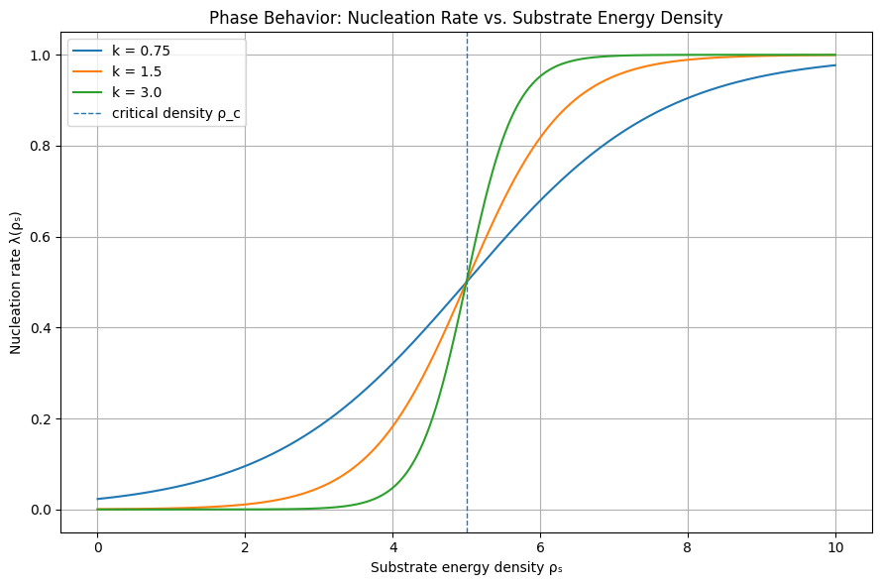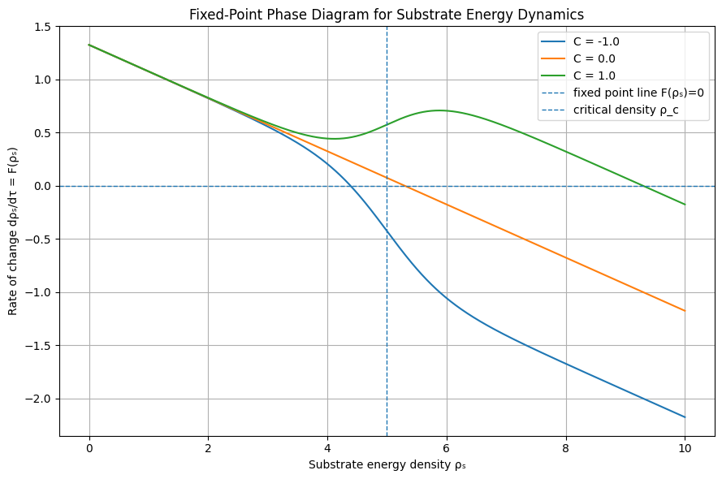

17. Demonstrated Result, Observational Anchor, and Model Contribution
17.1 Motivation
The preceding sections establish the dynamical framework of the substrate model, including the energy balance equation and stability condition. However, a formal condition alone is insufficient as a scientific result. This section provides a concrete numerical demonstration of a stable fixed point and anchors the model’s observational implications to existing cosmological search strategies.
17.2 Toy Numerical Demonstration of a Stable Fixed Point
Consider the substrate evolution equation:
dρₛ/dτ = R(ρₛ) + Cλ(ρₛ) − Γ(ρₛ − ρ_eq)
with:
C = ηEᵤ − Eₙ
and nucleation rate:
λ(ρₛ) = λ_max / [1 + exp(−k(ρₛ − ρ_c))]
Choose the following illustrative parameter values:
ρ_c = 5
λ_max = 1
k = 2
ρ_eq = 4.5
Γ = 0.25
R(ρₛ) = 0.2
C = −1
Here, C < 0 represents a regime in which nucleation extracts more energy than it returns, producing negative feedback.
The equilibrium condition is:
0 = 0.2 − λ(ρₛ*) − 0.25(ρₛ* − 4.5)
Solving numerically yields:
ρₛ* ≈ 4.39
At this value:
λ(4.39) = 1 / [1 + exp(−2(4.39 − 5))] ≈ 0.228
Substituting into the dynamical equation:
F(4.39) = 0.2 − 0.228 − 0.25(4.39 − 4.5)
F(4.39) ≈ 0.2 − 0.228 + 0.0275 ≈ −0.0005 ≈ 0
This verifies that ρₛ* is a fixed point.
To evaluate stability, compute:
λ′(ρₛ) = kλ(ρₛ)[1 − λ(ρₛ)/λ_max]
λ′(4.39) = 2(0.228)(1 − 0.228) ≈ 0.352
F′(4.39) = Cλ′(4.39) − Γ = −0.352 − 0.25 ≈ −0.602
Since F′(4.39) < 0, the fixed point is stable.
This provides a concrete demonstration that the model supports a stable regime with continuous but regulated universe nucleation.

17.3 Interpretation of the Demonstrated Result
The numerical example shows that the substrate need not either collapse into dormancy or enter runaway universe production. Under negative feedback, the substrate can settle into a regulated regime.
This supports the claim that continuous universe creation can be modeled as a self-regulating dynamical process rather than an unconstrained random process.
The example remains a toy model. Its value is not that the chosen numbers represent measured cosmological constants, but that the framework produces stable behavior under explicit and reproducible assumptions.

17.4 Concrete Observational Anchor: CMB Bubble Collision Searches
The most plausible observational connection for this model is through searches for bubble collision signatures in the cosmic microwave background.
Feeney, Johnson, Mortlock, and Peiris (2011) developed statistical methods to detect bubble collision imprints in CMB data and applied them to WMAP observations. These studies searched for localized circular temperature anomalies and edge-like features consistent with collision templates.
Relevant references:
Feeney, S. M., Johnson, M. C., Mortlock, D. J., & Peiris, H. V. (2011). First Observational Tests of Eternal Inflation. Physical Review Letters, 107, 071301.
Feeney, S. M., Johnson, M. C., Mortlock, D. J., & Peiris, H. V. (2011). First Observational Tests of Eternal Inflation Using WMAP Data. Physical Review D, 84, 043507.
arXiv:1012.3667
These works provide an established observational framework against which alternative nucleation models can be compared.

17.5 Distinguishing Prediction
Standard bubble nucleation models assume a constant rate, producing a Poisson distribution of independent events.
In contrast, this model introduces:
λ = λ(ρₛ)
This coupling implies that nucleation events influence future nucleation probabilities.
Therefore, if collision signatures are observable, this model predicts deviations from purely random distributions, including:
spatial clustering beyond constant-rate expectations,
suppression zones in regions where prior nucleation has reduced local substrate energy,
and burst-like episodes of increased nucleation.
The suppression effect follows directly from the substrate energy balance: prior nucleation events reduce local ρₛ through the energy extraction term λ(ρₛ)Eₙ. Until the substrate recovers via regeneration or damping processes, the local nucleation probability remains suppressed.
Thus, the key prediction is not the existence of bubble signatures, but the presence of non-Poisson statistical structure in their distribution.

17.6 Model Contribution
The contribution of this framework is specific and limited in scope.
It introduces:
a density-dependent nucleation law,
a thermodynamic substrate model,
a demonstrated stable fixed point under explicit assumptions,
and a statistical distinction from constant-rate nucleation models.
It does not derive λ from first principles and does not claim observational confirmation of other universes.
Instead, it provides a framework for comparing feedback-regulated nucleation against standard Poisson models.

17.7 Limitations
This demonstrated result is mathematical rather than empirical. The numerical values are illustrative and do not represent measured properties of a physical substrate.
The observational prediction is conditional. It only becomes testable if bubble collision signatures are detectable and distinguishable from foregrounds, instrumental artifacts, and standard cosmological fluctuations.
Future work must derive λ(ρₛ) from a deeper theory, simulate feedback-regulated nucleation populations, and compare those simulations against CMB search methods such as those used in existing bubble collision studies.

17.8 Summary
The framework is intentionally limited in scope but produces concrete, reproducible results and a specific empirical comparison strategy. The model demonstrates stable self-regulated universe nucleation under explicit toy assumptions and identifies a concrete observational comparison class: non-Poisson structure in CMB bubble collision candidates.
This does not prove the model correct, but it gives the framework a derived result and a more specific route toward empirical comparison.

